Project Plan Report

Bora Girbay, Douglas Martiniuk, Dylan Corless
Kevin Ranaweera, Jawan Toor, Karen Joy Tragura
ITSA, NAIT
A06.1252
PMIT-1027: IT Project Essentials
Reg Westly
April 17, 2026

Table of Contents
Group 6 End of Term LAN Party Project Plan Report 3
Executive Summary 3
Project Overview 4
Context and Background 4
Main Objectives 4
Assumptions 4
Constraints 5
Scope Overview 7
Scope Statement 7
In Scope: 7
Out of Scope: 7
Work Breakdown Structure (WBS) 9
Project Schedule (Gantt Chart) 10
Roles and Responsibilities (RACI Chart) 11
Change Management Plan 12
Process 12
How Are Change Requests Handled? 13
Change Request Form 13
Change Form Example 14
Risk Register 16
Procurement Plan 18
Communication Plan 19
Appendices 20
Appendices A – WBS Chart 20
Appendices B – Project Schedule 25
Appendices C – Gantt Chart 34
Appendices D – RACI Chart 36
Appendices E – Change Request Form 41
Appendices F – Risk Matrix 43

Group 6 End of Term LAN Party Project Plan Report

Executive Summary
The End of Term LAN Party, scheduled for April 24, 2026, is designed to combat student burnout and mental fatigue at NAIT by providing a dedicated social space for relaxation and peer connection. By utilizing a mix of six Nintendo Switch or Nintendo Switch 2 gaming stations, we are holding an event that does away with competitive stressors in favor of a free play environment supported by interactive quest cards to drive overall guest engagement. The project aims to achieve a seamless 48-day timeline, 100% equipment uptime, and a measurable reduction in attendee stress levels verified by pre and post event survey data.

Project Overview

Context and Background
This project addresses the increase in stress and mental fatigue experienced by NAIT students by the end of the term. Group 6 aims to mitigate this by hosting a console-based LAN party on April 24th, 2026, providing a dedicated social space for students to decompress and connect with their peers. Unlike traditional competitive gaming events, this project focuses on more of a free play environment, anyone can play any game at any time; they’ll just have to wait for a free space. To maximize inclusivity and promote a stress-free atmosphere as the term ends.

Main Objectives
- Event Execution
  - Coordinate and execute a one-day console-based LAN party on April 24, 2026, adhering to our 48-day timeline
  - Successfully manage the setup and teardown of the event within an 8-hour window
  - Ensure 100% uptime for all gaming stations through pre-event testing and onsite volunteer/group member based technical support
- Engagement
  - Provide a diverse game selection across six gaming stations (Nintendo Switch and Nintendo Switch 2) to cater to a wide range of student interests
  - Implement a rotation based free play system to ensure all attendees have equal access to gaming hardware throughout the event
  - Maintain a welcoming, inclusive social environment that encourages interaction between attendees
- Student Well Being
  - Address end of term burnout by providing a fun inclusive environment
  - Utilize pre and post event surveys to collect data on attendee stress levels before and after the event. This will let us know our event was successful
  - Promote a noncompetitive atmosphere that prioritizes fun and relaxation over competitive gameplay
- Participation
  - Drive activity through the quest cards. These require students to complete social or gaming tasks to qualify for prizes. It ensures that attendees will be able to connect with other people during the event
  - Distribute sponsor provided and team acquired prizes fairly, by the completion of the quest cards by attendees, incentivizing participation throughout the event

Assumptions
- Venue & Infrastructure:
  - The venue at NAIT will have adequate power outlets and provide high speed internet
  - HVAC system is adequate to offset the heat generated by all the equipment running
  - We will be able to access the venue beforehand to create our layout, and do our pre-event tests
  - The venue space will be able to fit six gaming stations, check in area, drink and beverage area, and a sitting area
  - The venue will be rented at no cost
  - NAIT will be able to provide some equipment with the venue rental at no cost
- Sponsorships
  - We will be able to secure at least one sponsor donate a prize for our event and it will be able to provide it 48 hours before the event
  - We will receive all sponsor logos by March 13 to ensure they are included in the initial marketing wave
- Budget
  - We will be able to get the required funding for the event
  - We will be able to get funding from sponsors
- Volunteers
  - We will be able to recruit 12 volunteers by April 20, 2026
  - The volunteers will join the volunteer discord so they can be updated
  - All volunteers will show up on time on April 24, 2026, so they can be trained and assigned their roles before the event
  - All volunteers will do their work for free
- Marketing
  - We will be able to create all marketing materials in a week
  - Sponsors will provide their assets by March 13, 2026
  - Students will see our posters or social media posts and be interested in the event
  - We will be able to get students to follow and share our social media account or join our discord server so they can get event updates
  - We will be able to post weekly reminders to social media and discord
- Attendees
  - There will be students that sign up using the registration form
  - Attendees will show up on the event day, April 24, 2026
  - There will be a quantitative decrease in attendee stress levels, determined by pre and post event surveys
  - Attendees will fill out the surveys and complete quest cards
- Borrowing/Renting Equipment
  - We will be able to borrow equipment from other students
  - All rental vendors will have the equipment required available for the requested dates without any substitutions
  - All equipment, borrowed or rented, will be fully updated before being handed over to the team
  - All equipment will be returned in the same condition as it was received
- Event Day
  - We will have 100% equipment uptime during the event
  - We will be able to troubleshoot any issues quickly
  - NAIT’s network will remain stable and have enough bandwidth
  - We will be able to get in contact with someone from NAIT if there are any issues with the network or venue
  - At least 80% of those registered will arrive within the first two hours
  - All attendees will follow the code of conduct and treat the equipment as their own

Constraints
- Schedule
  - We have a fixed date for the event, April 24th. Any delay in the critical path could possibly affect our ability to hold the event on that day
  - We only have a three-week window between the procurement of the equipment and the event
- Scope
  - We are limiting the event to six gaming stations; we can’t increase the number of stations without booking a larger space or an increased budget
  - We are limiting the event to strictly being console based (Nintendo Switch/Switch 2). PC games or other consoles will not be considered
  - We are limiting the event to free play only; we want it to be a fun environment not a stressful one
- Budget
  - All spending is limited to our preapproved budget, no personal funds from the team will be used
  - As this is a free event we are unable to make any revenue to offset any costs, so the budget must be secured before we move past the planning stage
- Resources
  - Our project is limited to our six group members and the 12 volunteers we are recruiting
  - All troubleshooting must be performed by either the group members or volunteers; we can’t hire external IT help to limit the budget. Our program is all about troubleshooting, so it applies what we have been learning in class
- Venue
  - The venue will have an occupancy limit which will limit how many attendees will be able to register and possibly have to turn away unregistered attendees
  - The layout for our gaming stations will be limited by the room layout and power outlet and ethernet port locations
  - We can only access the venue while NAIT is open
  - We must comply with any NAIT venue and security policies

Scope Overview

Scope Statement
The objective of this project is to plan and execute a one-day LAN party at NAIT on April 24th, 2026, to provide a social gaming environment for students to destress.

In Scope:
- Venue Booking: Securing a room at NAIT, creating a room layout document and verifying the power load
- Marketing Asset Creation: Designing all the posters, social media content, and the registration portal
- Marketing and Registration: Executing the marketing campaign across multiple channels and managing the attendee sign up process
- Volunteers: Recruiting, training, and assigning roles to at least 12 volunteers for event support
- Equipment: Procuring, testing, and setting up all the required equipment for the event
- Event programming: A free play schedule to ensure that students can rotate through all the gaming stations throughout the event.
- Pre and Post Event Surveys: Creating and distributing surveys to gauge student stress levels before and after the event
- Quest Cards: Create quest cards, cards that have three tasks for attendees to complete to earn an entry into the prizes.
- Prizes: Either sponsor provided or team acquired prizes for the event
- Post-Event Reporting: Compiling final project metrics, incident logs, and closure documents

Out of Scope:
- Formal/Competitive Tournaments: To ensure a casual environment and simplify logistics, the team will not host ranked, bracketed, or professionally moderated competitive tournaments
- Personal Computers: This is a plug and play event all equipment will be provided for attendees
- External Network Infrastructure: The project team will not be responsible for NAIT’s Wi-Fi or hardwired networks
- External Technical Support: Support will be limited to procured equipment. We will not be able to provide technical support for attendee’s personal devices
- Full Catering: The team will provide snacks and drinks. Coordinating full meals, or food delivery is not part of the scope
- Travel and Logistics: The project team will not provide or reimburse transportation for volunteers, attendees, or sponsors to and from NAIT.
- Hardware Liability: The project team is not responsible for any damage, theft, or loss of any personal items brought into the venue by attendees
- Post-Event Venue Management: Beyond tear down and cleaning up the room used for the event, the project team is not responsible for cleaning up or maintaining NAIT hallways, restrooms, or other areas on campus

Work Breakdown Structure (WBS)
Our project was organized into a seven phase WBS that covers our project from our initial research (Task 1.0) to our post event wrap up (Task 7.0).
To view our complete Work Breakdown Structure Table please refer to:
Appendices A – Work Breakdown Structure Table
Work Breakdown Structure Spreadsheet

Project Schedule (Gantt Chart)
Our project follows a fixed 48-day timeline, starting on March 2, 2026, ensuring that our event occurs on April 24, 2026, and gives us until May 6, 2026, for final wrap up tasks. We assigned timelines for each task and determined dependencies to create our critical path for our project, which allows us to determine if our project is on time or starting to fall behind.
For our complete Project Schedule please refer to:
Appendices B - Project Schedule Table
Appendices C – Gantt Chart Images
Project Schedule .mpp file

Roles and Responsibilities (RACI Chart)
To ensure accountability across our team of six, 12 volunteers, and our stakeholders we developed a formal RACI Chart to define who was Responsible (R), Accountable (A), Consulted (C), and Informed (I) for every task in our schedule. We ensured that the task owners were accountable and responsible (A/R). This makes it easy to see who the lead on each task is. We also mapped out our stakeholders, Attendees, Volunteers, NAIT, and our sponsors, and ensured they were either responsible, consulted, or informed of updates.
To view our complete RACI Chart please refer to:
Appendices D – RACI Chart
RACI Chart Spreadsheet

Change Management Plan

Process
The Change Management Process ensures that any modifications to the LAN Party project are properly reviewed, approved, and implemented without negatively impacting the event’s timeline, budget, or objectives. This process helps maintain organization and minimizes risks while allowing flexibility when needed.
- Change Request Submission
- Any team member or stakeholder can submit a change request.
- Requests must be documented using a Change Request Form.
- The request should include:
- Description of the proposed change
- Reason for the change
- Expected impact (schedule, cost, resources, scope)
- Priority level (low, medium, high)
- Initial Review
- The Project Lead reviews the request for completeness.
- If information is missing, the request is returned for clarification.
- Valid requests move to the evaluation stage.
- Impact fAnalysis
- The team evaluates how the change affects:
- Event schedule (e.g., setup time, event duration)
- Budget (equipment, snacks, venue costs)
- Resources (consoles, controllers, volunteers)
- Scope (event size, number of participants)
- Risks associated with the change are identified.
- Decision Making
- The team decides based on impact, feasibility, and alignment with project goals to:
- Approve – change will be implemented
- Reject – change will not be implemented
- Defer – decision postponed for later review
- Communication
- The decision is communicated to all team members.
- If the change affects participants or logistics, updates are shared through appropriate channels (e.g., Discord, email, posters).
- Implementation
- Approved changes are added to the project plan.
- Responsibilities are assigned to team members.
- Necessary adjustments (schedule, equipment, layout) are made.
- Documentation and Tracking
- All change requests (approved or rejected) are logged in a Change Log.
- The log includes:
- Request ID
- Description
- Decision
- Date
- Name of change requester
- Change Owner

How Are Change Requests Handled?
- A team member or stakeholder identifies a change.
- A formal change request is submitted with all required details.
- The project lead reviews the request for completeness.
- The team conducts an impact analysis (time, cost, scope, risk).
- A decision is made (approve, reject, or defer).
- The outcome is communicated through all channels, as necessary.
- If approved, the change is implemented and assigned to team members.
- The change and its outcome are recorded in the Change Log.

Change Request Form
Appendices E – Change Request Form

Change Form Example
NAIT LAN Party Change Request Form
Change Request ID: 1
Date Submitted: April 9, 2026
Requester Name: Timmy Tommy
Priority Level:
☐ Low (Minor tweak, no impact on event date)
☐ Medium (Adjusts logistics or internal team workflow)
☒ High (Critical, affects budget, venue, or attendee experience)
Description of Proposed Change:
You should have a competitive Smash Bros Melee tournament with prizes for the top 3! It wouldn’t be an event without a Melee tournament.
Reason for Change:
I think it would be fun and drive a lot of engagement
Impact
Area of Impact | Description of Effect
☒ Event Schedule | You would have to be schedule it into the event
☒ Budget | You would need money for the prizes
☒ Resources | You would need GameCubes, copies of Melee, GameCube controllers, and CRT TVs
☒ Scope | You would have to plan a tournament

Risk Assessment
What happens if we do (or don’t) do this?
People may not want to attend your event if there is no Melee. People love it and it’s a huge draw!

Decision and implementation
To be completed by the Project Lead
Final Decision:
☐ Approve (Proceed to implementation)
☒ Reject (Archive in change log)
☐ Defer (Review again on date: )
Decision Rationale:
We have already determined that a tournament is out of scope for our event. While it would be fun, we are trying to minimize our costs for this event.
Change Owner (If approved)
N/A
Sign Off:
Project Lead Signature: Dylan Corless
Date: April 9, 2026

Risk Register
Appendices F – Risk Matrix

Risk Statement | Category | Probability | Impact | Priority | Mitigation Plan | Contingency Plan | Risk Owner | Monitoring Notes
Poster Printing Error | Marketing | Low | High | High | Ensure there is enough time between printing and posting posters | Post correction notices on discord and social media. Have the posters be reprinted | Bora | Bora will verify posters with print shop when the order is placed and 24 hours before pickup
Game/DLC Issues  (Account issues or missing updates) | Technical | Medium | High | High | Ensure all games and equipment are updated and the proper accounts have the DLC the night before the event | Have that station be out of service until the issue is resolved | Douglas | Douglas will verify that every console and game is fully updated, download required DLC during the final tech test on April 23
Lack of Volunteers | Resource | Medium | High | High | Ensure volunteer recruitment starts on time, try and overrecruit by 20% | Have team members fill in for any missing volunteers | Dylan | Dylan will do a weekly audit of the volunteer registration starting March 23
Inadequate Food/Beverages | Resource | Medium | Medium | Medium | Ensure the data from the food and beverage survey is thoroughly gone through before food/beverage is bought | Use the contingency fund to have a team member go buy emergency food / beverages | Karen | Karen will compare the total registration count with the food and beverage survey results to get an accurate count on April 22
Missing Equipment  (Controllers, Consoles, TV) | Resource | Low | High | High | Have backup controllers and equipment available, borrow more controllers and equipment than is needed just in case | Rent emergency gear and put out an emergency request to borrow missing gear, go out and buy missing gear with contingency fund | Kevin | Kevin will conduct a physical inventory count on April 23 so we can follow up on any missing gear by event day

Procurement Plan
Item | Procurement Method | Cost Level | Required Approvals | Lead Time | Dependencies | Procurement Risks
Gaffers Tape | Direct Buy | Low | Kevin | 6 Days | WBS 3.2 | Required brand or residue free tape is out of stock
Games + DLC | Direct Buy | High | Kevin | 6 Days | WBS 1.5, 1.5.1 | Can’t get all the games or DLC
Network Switch | Direct Buy | Medium | Douglas | 6 Days | WBS 1.1.1 | Hardware may be incompatible with NAIT’s network security or DHCP settings
Drinks and Snacks | Direct Buy | Medium | Karen | 1 Day | WBS 2.7, 4.1 | Inadequate quantity for turnout (More or Less)
Poster printing | Direct Buy | Low | Bora | 1 Day | WBS 4.1.1 | Printing error or printer missed the 24-hour turnaround
Volunteer Lanyards | Direct Buy | Low | Kevin | 6 Days | WBS 6.3 | Shipping delays or incorrect quantities ordered for the final volunteer count

Cost Levels:
Low – $0 - $100
Medium - $100 - $200
High - $200+

Communication Plan
Communication Statement:
Group 6 will ensure all stakeholders stay informed through weekly Teams meetings, discord, and social media messages, with owners assigned to each update to maintain alignment with our RACI chart and project goals.
Communication Matrix:
Communication Type | Owner | Stakeholders | Frequency | Method
Initial Team Meeting | Dylan | Group 6 | March 3, 2026 | In Person
Weekly Progress Meetings | Dylan | Group 6 | Weekly | Teams
Change Notifications | Dylan | Group 6, NAIT (If venue related) | Within 24 Hours of change | Email, Teams Meeting
Sponsor Communication | Bora | Group 6, Sponsors | As required by sponsors | Email or Phone Calls
Event Information/  Marketing | Bora | Attendees | Weekly | Social Media, Discord
Volunteer Coordination | Dylan | Group 6, Volunteers | Weekly | Discord
Equipment & Vendor Coordination | Kevin, Vendors, Sponsors | Group 6 | April 10, 2026  April 17, 2026 | Teams (Group 6), Email/Phone (Vendors/Sponsors)
Pre-event Walkthrough | Douglas | Group 6, NAIT | April 23, 2026 | In Person (Group 6), Email (NAIT)
Pre-event Setup | Douglas | Group 6, NAIT, Volunteers | April 24, 2026 | In Person (Group 6), Email (NAIT)
Volunteer Training | Dylan | Group 6, Volunteers | April 24, 2026 | In Person
Day of Event Coordination | Jawan | Group 6, NAIT Security, Volunteers | April 24, 2026 | In Person, Discord, Phone
Post-Event Walkthrough | Douglas | Group 6, NAIT | April 24, 2026 | In Person (Group 6), Email (NAIT)
Final Team Meeting + Event Debrief | Dylan | Group 6, NAIT, Sponsors | May 6, 2026 | In person (Group 6), Email (NAIT and Sponsors)

Appendices

Appendices A – WBS Chart
WBS ID | Task Name | Owner | Duration (Days) | Notes
0.0 | NAIT End of Term LAN Party | Group 6 | 48 days
1.0 | Research LAN Party | Jawan | 5 days
1.1 | Research equipment needed | Jawan | 1 day
1.1.1 | Research network and power requirements for equipment | Jawan | 1 day
1.1.2 | Research peripherals required | Jawan | 1 day
1.2 | Research how to book room at NAIT | Karen | 3 days
1.2.1 | Inquire about capacity limits | Karen | 3 days
1.2.2 | Inquire about equipment that can be provided by NAIT | Karen | 3 days
1.3 | Research possible sponsors | Bora | 1 day
1.3.1 | Create a sponsor pitch deck | Bora | 1 day
1.4 | Research possible vendors | Kevin | 1 day
1.5 | Research games that will be played | Dylan | 1 day
1.5.1 | Research any DLC that would be required | Dylan | 1 day
1.6 | Research ways to distribute survey | Douglas | 2 days
1.7 | Research NAIT IT policies | Douglas | 1 day
1.8 | Research NAIT food policies | Douglas | 1 day
1.9 | Research volunteer recruitment channels | Karen | 1 day
1.9.1 | Research volunteer roles required | Karen | 1 day
1.10 | Research NAIT security policies | Kevin | 1 day
1.11 | Research prizes | Kevin | 1 day
1.12 | Compile costs | Kevin | 1 day | confirm total costs
 | Research LAN Party complete |  | 0 days
2.0 | Plan LAN Party | Dylan | 34 days
2.1 | Create volunteer roles | Dylan | 1 day | volunteers confirmed
2.1.1 | Create volunteer training manual | Dylan | 1 day
2.1.2 | Create a discord for volunteer communication | Dylan | 1 day
2.2 | Volunteer recruitment | Bora | 1 day | Try to hit goal of 12 volunteers
2.2.1 | Confirm volunteers and availability | Bora | 1 day
2.2.2 | Create volunteer schedule | Bora | 1 day
2.3 | Create a run of show schedule | Dylan | 1 day
2.3.1 | Print run of show schedule for event and post on discord and social media | Dylan | 1 day
2.4 | Create a safety plan | Douglas | 1 day
2.4.1 | Print safety plan | Douglas | 1 day
2.5 | Create a code of conduct | Douglas | 3 days
2.5.1 | Print code of conduct for event | Douglas | 1 day
2.5.2 | Post code of conduct on event page | Douglas | 1 day
2.6 | Create registration form | Karen | 2 days
2.6.1 | Create QR code for registration form for marketing material | Karen | 1 day
2.7 | Create food and beverage survey | Karen | 2 days
2.7.1 | Create QR code for beverage survey for marketing material | Karen | 1 day
2.8 | Create pre and post event stress survey | Karen | 1 day
2.9 | Create quest cards | Karen | 1 day
2.10 | Contact potential sponsors | Kevin | 6 days
2.10.1 | Create sponsor tracking log | Kevin | 1 day
2.10.2 | Get sponsor logos for marketing materials | Kevin | 1 day
2.11 | Create an incident report form | Dylan | 1 day
2.12 | Create a budget | Dylan | 1 day
2.12.1 | Determine amount for contingency fund | Dylan | 1 day | 10% of total budget
2.13 | Create social media account | Jawan | 1 day | ookslife, Instagram
2.14 | Create a risk mitigation plan | Jawan | 1 day
2.15 | Create a walkthrough checklist | Jawan | 1 day
 | Plan LAN Party Complete |  | 0 days
3.0 | Venue | Douglas | 35 days
3.1 | Book Venue with NAIT | Douglas | 1 day
3.1.1 | Finalize venue booking | Douglas | 1 day
3.2 | Create layout plan for the event | Douglas | 1 day
3.2.1 | Verify power outlet locations | Douglas | 1 day
3.3 | Conduct pre-event walkthrough | Douglas | 1 day
3.3.1 | Go through walkthrough checklist | Douglas | 1 day
3.3.2 | Document any preexisting damage | Douglas | 1 day
3.4 | Conduct post event walkthrough | Douglas | 1 day
3.4.1 | Go through walkthrough checklist | Douglas | 1 day
 | Venue Complete |  | 0 days
4.0 | Marketing | Bora | 35 days
4.1 | Create marketing assets | Bora | 1 day
4.1.1 | Create Posters | Bora | 1 day
4.1.1.1 | Print posters | Bora | 1 day | 20 posters
4.1.2 | Create graphics for social media and discord posts | Bora | 1 day
4.2 | Post marketing assets around NAIT, discord, and social media | Bora | 33 days
4.2.1 | Launch registration form | Bora | 1 day
4.2.2 | Weekly event reminders on discord and social media | Bora | 30 days
4.4 | Create event signage | Bora | 1 day
4.4.1 | Create station signage | Bora | 1 day
 | Marketing Complete |  | 0 days
5.0 | Equipment | Kevin | 30 days
5.1 | Send out request for borrowing equipment on discord and social media | Kevin | 21 days | Need 6 consoles + 4 controllers per console and 6 TV’s
5.2 | Secure rentals for any missing consoles, peripherals, or tv's | Kevin | 1 day | Any missing consoles, controllers, and TVs
5.3 | Procure Equipment | Kevin | 6 days
5.3.1 | Procure switches | Douglas | 6 days
5.3.2 | Procure HDMI and Ethernet cables | Douglas | 6 days
5.3.3 | Procure gaffers tape | Douglas | 6 days
5.3.4 | Procure games | Douglas | 6 days
5.3.4.1 | Procure any DLC that is required | Douglas | 6 days
5.3.5 | Procure cable mats | Kevin | 6 days
5.3.6 | Procure extension cables | Kevin | 6 days
5.3.7 | Procure power bars | Kevin | 6 days
5.3.8 | Procure volunteer lanyards | Kevin | 6 days
5.3.9 | Procure hand sanitizer and disinfectant wipes | Kevin | 6 days
5.4 | Create equipment inventory sheet | Kevin | 1 day
5.5 | Label all equipment and cables | Kevin | 1 day
5.5.1 | Ensure all borrowed equipment has contact information | Kevin | 1 day | logged in excel
5.6 | Procure Prizes | Dylan | 1 day
5.7 | Procure food and beverage | Karen | 1 day
5.8 | Pre event tech test | Jawan | 1 day
5.8.1 | Power load test | Bora | 1 day
5.8.2 | Network connectivity test | Bora | 1 day
 | Equipment Complete |  | 0 days
6.0 | Hosting LAN Party | Group 6 | 2 days
6.1 | Load in equipment | Bora | 1 hr
6.2 | Physical setup | Douglas | 5 hrs
6.2.1 | Setup furniture | Douglas | 2 hrs
6.2.2 | Setup gaming stations | Kevin | 1 hr
6.2.3 | Cable management | Kevin | 1 hr
6.2.4 | Setup food and beverage table | Kevin | 0.5 hrs
6.2.5 | Final equipment and network test | Kevin | 1 hr
6.3 | Assign volunteers their roles | Dylan | 2 hrs
6.3.1 | Have safety meeting with volunteers | Dylan | 0.5 hrs
6.3.2 | Train volunteers | Dylan | 1.5 hrs
6.4 | Manage check in | Karen | 5 hrs
6.4.1 | Hand out quest cards | Karen | 5 hrs
6.4.1.1 | Take Completed Quest Cards | Karen | 5 hrs
6.4.2 | Remind guests about pre-event survey | Karen | 5 hrs
6.5 | Create event incident reports as needed | Jawan | 9 hrs | incident report doc shared with everyone
6.6 | Prize draw | Jawan | 0.5 hrs
6.7 | Post event survey | Karen | 1 hr
6.8 | Event teardown | Kevin | 4 hrs
6.8.1 | Return borrowed equipment | Kevin | 1 day
6.8.2 | Return rented equipment | Kevin | 1 day
 | Hosting LAN Party Complete |  | 0 days
7.0 | Post Event | Karen | 8 days
7.1 | Budget reconciliation | Karen | 3 days
7.1.1 | Collect all receipts | Karen | 1 day
7.1.2 | Update budget spreadsheet | Karen | 1 day | Enter actual cost vs planned
7.1.3 | Calculate final total + Remaining funds | Karen | 1 day
7.2 | Survey & Feedback analysis | Karen | 5 days
7.2.1 | Monitor Survey Responses | Karen | 5 days
7.2.2 | Send email reminder for survey | Karen | 4 days
7.2.3 | Summarize key metrics | Karen | 4 days | attendance feedback, enjoyment ratings etc
7.3 | Final Closeout | Karen | 1 day
7.3.1 | Publish/ Share event highlights (photos, recap) | Karen | 1 day
7.3.2 | Send thank you notes to stakeholders | Karen | 1 day
7.4 | Analyze event incident reports | Dylan | 1 day
7.5 | Create event report | Jawan | 8 days
7.5.1 | Compile Event statistics | Jawan | 1 day
7.5.2 | Add photos and media highlights | Jawan | 1 day
7.5.3 | Finalize PDF event report | Jawan | 1 day | share with stake holders
 | Post Event Complete |  | 0 days

Appendices B – Project Schedule
WBS | Task Name | Duration | Start | Finish | Predecessors | Resource Names
0 | NAIT End of Term LAN Party | 48 days | Mon 26-03-02 | Wed 26-05-06
1.0 | Research LAN Party | 5 days | Mon 26-03-02 | Fri 26-03-06 |  | Jawan
1.1 | Research equipment needed | 1 day | Mon 26-03-02 | Mon 26-03-02 |  | Jawan
1.1.1 | Research network and power requirements for equipment | 1 day | Mon 26-03-02 | Mon 26-03-02 |  | Jawan
1.1.2 | Research peripherals required | 1 day | Mon 26-03-02 | Mon 26-03-02 |  | Jawan
1.2 | Research how to book room at NAIT | 3 days | Mon 26-03-02 | Wed 26-03-04 |  | Karen
1.2.1 | Inquire about capacity limits | 3 days | Mon 26-03-02 | Wed 26-03-04 |  | Karen
1.2.2 | Inquire about equipment that can be provided by NAIT | 3 days | Mon 26-03-02 | Wed 26-03-04 |  | Karen
1.3 | Research Possible Sponsors | 1 day | Mon 26-03-02 | Mon 26-03-02 |  | Bora
1.3.1 | Create a sponsor pitch deck | 1 day | Tue 26-03-03 | Tue 26-03-03 |  | Bora
1.4 | Research possible vendors | 1 day | Mon 26-03-02 | Mon 26-03-02 |  | Kevin
1.5 | Research games that will be played | 1 day | Mon 26-03-02 | Mon 26-03-02 |  | Dylan
1.5.1 | Research any DLC that would be required | 1 day | Mon 26-03-02 | Mon 26-03-02 |  | Dylan
1.6 | Research ways to distribute survey | 2 days | Mon 26-03-02 | Tue 26-03-03 |  | Douglas
1.7 | Research NAIT IT policies | 1 day | Mon 26-03-02 | Mon 26-03-02 |  | Douglas
1.8 | Research NAIT food policies | 1 day | Mon 26-03-02 | Mon 26-03-02 |  | Douglas
1.9 | Research volunteer recruitment channels | 1 day | Mon 26-03-02 | Mon 26-03-02 |  | Karen
1.9.1 | Research volunteer roles required | 1 day | Mon 26-03-02 | Mon 26-03-02 |  | Karen
1.10 | Research NAIT security policies | 1 day | Mon 26-03-02 | Mon 26-03-02 |  | Kevin
1.11 | Research prizes | 1 day | Mon 26-03-02 | Mon 26-03-02 |  | Kevin
1.12 | Compile costs | 1 day | Fri 26-03-06 | Fri 26-03-06 | 2,4,8,10,11,12,19 | Kevin
1.0.M | Research LAN Party complete | 0 days | Fri 26-03-06 | Fri 26-03-06
2.0 | Plan LAN Party | 34 days | Thu 26-03-05 | Tue 26-04-21 | 1 | Dylan
2.1 | Create volunteer roles | 1 day | Mon 26-03-09 | Mon 26-03-09 | 16,17 | Dylan
2.1.1 | Create volunteer training manual | 1 day | Mon 26-03-09 | Mon 26-03-09 |  | Dylan
2.1.2 | Create a discord for volunteer communication | 1 day | Mon 26-03-09 | Mon 26-03-09 |  | Dylan
2.2 | Volunteer recruitment | 27 days | Mon 26-03-16 | Tue 26-04-21 | 23 | Bora
2.2.1 | Confirm volunteers and availability | 1 day | Mon 26-04-20 | Mon 26-04-20 |  | Bora
2.2.2 | Create volunteer schedule | 1 day | Tue 26-04-21 | Tue 26-04-21 |  | Bora
2.3 | Create a run of show schedule | 1 day | Fri 26-04-17 | Fri 26-04-17 | 21 | Dylan
2.3.1 | Print run of show schedule for event and post on discord and social media | 1 day | Mon 26-04-20 | Mon 26-04-20 |  | Dylan
2.4 | Create a safety plan | 1 day | Mon 26-03-09 | Mon 26-03-09 |  | Douglas
2.4.1 | Print safety plan | 1 day | Mon 26-03-09 | Mon 26-03-09 |  | Douglas
2.5 | Create a code of conduct | 3 days | Thu 26-03-12 | Mon 26-03-16 |  | Douglas
2.5.1 | Print code of conduct for event | 1 day | Thu 26-03-12 | Thu 26-03-12 |  | Douglas
2.5.2 | Post code of conduct on event page | 1 day | Mon 26-03-16 | Mon 26-03-16 |  | Douglas
2.6 | Create registration form | 2 days | Wed 26-03-11 | Thu 26-03-12 |  | Karen
2.6.1 | Create QR code for registration form for marketing material | 1 day | Thu 26-03-12 | Thu 26-03-12 |  | Karen
2.7 | Create food and beverage survey | 2 days | Wed 26-03-11 | Thu 26-03-12 | 15 | Karen
2.7.1 | Create QR code for beverage survey for marketing material | 1 day | Thu 26-03-12 | Thu 26-03-12 |  | Karen
2.8 | Create pre and post event stress survey | 1 day | Tue 26-04-14 | Tue 26-04-14 |  | Karen
2.9 | Create quest cards | 1 day | Wed 26-04-15 | Wed 26-04-15 |  | Karen
2.10 | Contact potential sponsors | 6 days | Fri 26-03-06 | Fri 26-03-13 | 8,9 | Kevin
2.10.1 | Create sponsor tracking log | 1 day | Fri 26-03-06 | Fri 26-03-06 | 8 | Kevin
2.10.2 | Get sponsor logos for marketing materials | 1 day | Fri 26-03-13 | Fri 26-03-13 |  | Kevin
2.11 | Create an incident report form | 1 day | Fri 26-04-17 | Fri 26-04-17 |  | Dylan
2.12 | Create a budget | 1 day | Mon 26-03-09 | Mon 26-03-09 | 42,20,19 | Dylan
2.12.1 | Determine amount for contingency fund | 1 day | Mon 26-03-09 | Mon 26-03-09 | 20 | Dylan
2.13 | Create social media account | 1 day | Mon 26-03-09 | Mon 26-03-09 |  | Jawan
2.14 | Create a risk mitigation plan | 1 day | Mon 26-03-09 | Mon 26-03-09 |  | Jawan
2.15 | Create a walkthrough checklist | 1 day | Thu 26-03-05 | Thu 26-03-05 | 5,6,7,10,11,12,14,15 | Jawan
2.0.M | Plan LAN Party Complete | 0 days | Thu 26-04-23 | Thu 26-04-23
3.0 | Venue | 35 days | Mon 26-03-09 | Fri 26-04-24 | 10,14,15,51,5,6,7,18 | Douglas
3.1 | Book Venue with NAIT | 1 day | Mon 26-03-09 | Mon 26-03-09 | 5 | Douglas
3.1.1 | Finalize venue booking | 1 day | Mon 26-03-16 | Mon 26-03-16 |  | Douglas
3.2 | Create layout plan for the event | 1 day | Thu 26-04-23 | Thu 26-04-23 |  | Douglas
3.2.1 | Verify power outlet locations | 1 day | Thu 26-04-23 | Thu 26-04-23 |  | Douglas
3.3 | Conduct pre-event walkthrough | 1 day | Thu 26-04-23 | Thu 26-04-23 | 50 | Douglas
3.3.1 | Go through walkthrough checklist | 1 day | Thu 26-04-23 | Thu 26-04-23 | 50 | Douglas
3.3.2 | Document any preexisting damage | 1 day | Thu 26-04-23 | Thu 26-04-23 | 50 | Douglas
3.4 | Conduct post event walkthrough | 1 day | Fri 26-04-24 | Fri 26-04-24 | 97,57,58,59 | Douglas
3.4.1 | Go through walkthrough checklist | 1 day | Fri 26-04-24 | Fri 26-04-24 | 50 | Douglas
3.0.M | Venue Complete | 0 days | Fri 26-04-24 | Fri 26-04-24
4.0 | Marketing | 35 days | Mon 26-03-09 | Fri 26-04-24 | 33,37,39,44,46,53,54 | Bora
4.1 | Create marketing assets | 1 day | Mon 26-03-09 | Mon 26-03-16 |  | Bora
4.1.1 | Create Posters | 1 day | Mon 26-03-09 | Mon 26-03-16 |  | Bora
4.1.1.1 | Print posters | 1 day | Mon 26-03-09 | Mon 26-03-16 |  | Bora
4.1.2 | Create graphics for social media and discord posts | 1 day | Tue 26-03-09 | Tue 26-03-16 | 48 | Bora
4.2 | Post marketing assets around NAIT, discord, and social media | 33 days | Wed 26-03-11 | Fri 26-04-24 | 65,66,67,48 | Bora
4.2.1 | Launch registration form | 1 day | Wed 26-03-11 | Wed 26-03-11 | 36 | Bora
4.2.2 | Weekly event reminders on discord and social media | 30 days | Mon 26-03-16 | Fri 26-04-24 | 48,67 | Bora
4.4 | Create event signage | 1 day | Mon 26-04-20 | Mon 26-04-20 |  | Bora
4.4.1 | Create station signage | 1 day | Mon 26-04-20 | Mon 26-04-20 |  | Bora
4.0.M | Marketing Complete | 0 days | Fri 26-04-24 | Fri 26-04-24
5.0 | Equipment | 30 days | Mon 26-03-16 | Fri 26-04-24 | 63,2,3,4,10,11,12,46 | Kevin
5.1 | Send out request for borrowing equipment on discord and social media | 21 days | Mon 26-03-16 | Mon 26-04-13 | 68,69,70 | Kevin
5.2 | Secure rentals for any missing consoles, peripherals, or tv's | 1 day | Mon 26-04-13 | Mon 26-04-13 | 10 | Kevin
5.3 | Procure Equipment | 6 days | Fri 26-04-10 | Fri 26-04-17 | 46 | Kevin
5.3.1 | Procure switches | 6 days | Fri 26-04-10 | Fri 26-04-17 | 3 | Douglas
5.3.2 | Procure HDMI and Ethernet cables | 6 days | Fri 26-04-10 | Fri 26-04-17 | 4 | Douglas
5.3.3 | Procure gaffers tape | 6 days | Fri 26-04-10 | Fri 26-04-17 |  | Douglas
5.3.4 | Procure games | 6 days | Fri 26-04-10 | Fri 26-04-17 | 11 | Douglas
5.3.4.1 | Procure any DLC that is required | 6 days | Fri 26-04-10 | Fri 26-04-17 | 12 | Douglas
5.3.5 | Procure cable mats | 6 days | Fri 26-04-10 | Fri 26-04-17 |  | Kevin
5.3.6 | Procure extension cables | 6 days | Fri 26-04-10 | Fri 26-04-17 | 3,4 | Kevin
5.3.7 | Procure power bars | 6 days | Fri 26-04-10 | Fri 26-04-17 | 3,4 | Kevin
5.3.8 | Procure volunteer lanyards | 6 days | Fri 26-04-10 | Fri 26-04-17 | 26 | Kevin
5.3.9 | Procure hand sanitizer and disinfectant wipes | 6 days | Fri 26-04-10 | Fri 26-04-17 |  | Kevin
5.4 | Create equipment inventory sheet | 1 day | Tue 26-04-14 | Tue 26-04-14 | 75,76,77 | Kevin
5.5 | Label all equipment and cables | 1 day | Thu 26-04-23 | Thu 26-04-23 | 77 | Kevin
5.5.1 | Ensure all borrowed equipment has contact information | 1 day | Thu 26-04-23 | Thu 26-04-23 | 75,76 | Kevin
5.6 | Procure Prizes | 1 day | Thu 26-04-23 | Thu 26-04-23 | 19 | Dylan
5.7 | Procure food and beverage | 1 day | Thu 26-04-23 | Thu 26-04-23 | 38 | Karen
5.8 | Pre event tech test | 1 day | Thu 26-04-23 | Thu 26-04-23 |  | Jawan
5.8.1 | Power load test | 1 day | Thu 26-04-23 | Thu 26-04-23 |  | Bora
5.8.2 | Network connectivity test | 1 day | Thu 26-04-23 | Thu 26-04-23 |  | Bora
5.0.M | Equipment Complete | 0 days | Fri 26-04-24 | Fri 26-04-24
6.0 | Hosting LAN Party | 2 days | Fri 26-04-24 | Sat 26-04-25 | 73,74,88,89,93,96 | Group 6
6.1 | Load in equipment | 1 hr | Fri 26-04-24 | Fri 26-04-24 | 96 | Bora
6.2 | Physical setup | 5 hrs | Fri 26-04-24 | Fri 26-04-24 | 98,96 | Douglas
6.2.1 | Setup furniture | 2 hrs | Fri 26-04-24 | Fri 26-04-24 | 53,54 | Douglas
6.2.2 | Setup gaming stations | 1 hrs | Fri 26-04-24 | Fri 26-04-24 | 75,76 | Kevin
6.2.3 | Cable management | 1 hr | Fri 26-04-24 | Fri 26-04-24 | 79,80,83,84,85 | Kevin
6.2.4 | Setup food and beverage table | 0.5 hrs | Fri 26-04-24 | Fri 26-04-24 | 92 | Kevin
6.2.5 | Final equipment and network test | 1 hr | Fri 26-04-24 | Fri 26-04-24 |  | Kevin
6.3 | Assign volunteers their roles | 2 hrs | Fri 26-04-24 | Fri 26-04-24 | 108 | Dylan
6.3.1 | Have safety meeting with volunteers | 0.5 hrs | Fri 26-04-24 | Fri 26-04-24 | 31 | Dylan
6.3.2 | Train volunteers | 1.5 hrs | Fri 26-04-24 | Fri 26-04-24 | 24 | Dylan
6.4 | Manage check in | 5 hrs | Fri 26-04-24 | Fri 26-04-24 | 114 | Karen
6.4.1 | Hand out quest cards | 5 hrs | Fri 26-04-24 | Fri 26-04-24 | 41 | Karen
6.4.1.1 | Take completed quest cards | 5 hrs | Fri 26-04-24 | Fri 26-04-24 |  | Karen
6.4.2 | Remind guests about pre-event survey | 5 hrs | Fri 26-04-24 | Fri 26-04-24 | 40 | Karen
6.5 | Create event incident reports as needed | 9 hrs | Fri 26-04-24 | Fri 26-04-24 | 45 | Jawan
6.6 | Prize draw | 0.5 hrs | Fri 26-04-24 | Fri 26-04-24 | 91 | Jawan
6.7 | Post event survey | 1 hr | Fri 26-04-24 | Fri 26-04-24 | 115 | Karen
6.8 | Event teardown | 2 hrs | Fri 26-04-24 | Fri 26-04-24 |  | Kevin
6.8.1 | Return borrowed equipment | 1 day | Fri 26-04-24 | Fri 26-04-24 | 75,76 | Kevin
6.8.2 | Return rented equipment | 1 day | Mon 26-04-27 | Mon 26-04-27 | 90 | Kevin
6.0.M | Hosting LAN Party Complete | 0 days | Mon 26-04-27 | Mon 26-04-27
7.0 | Post Event | 8 days | Fri 26-04-24 | Wed 26-05-06 | 118 | Karen
7.1 | Budget reconciliation | 3 days | Mon 26-04-27 | Wed 26-04-29 | 118 | Karen
7.1.1 | Collect all receipts | 1 day | Mon 26-04-27 | Mon 26-04-27 | 118 | Karen
7.1.2 | Update budget spreadsheet | 1 day | Tue 26-04-28 | Tue 26-04-28 | 121 | Karen
7.1.3 | Calculate final total + Remaining funds | 1 day | Wed 26-04-29 | Wed 26-04-29 | 122 | Karen
7.2 | Survey & Feedback analysis | 5 days | Mon 26-04-27 | Fri 26-05-01 | 118 | Karen
7.2.1 | Monitor Survey Responses | 5 days | Fri 26-04-24 | Fri 26-05-01 | 111,114 | Karen
7.2.2 | Send email reminder for survey | 4 days | Mon 26-04-27 | Thu 26-04-30 |  | Karen
7.2.3 | Summarize key metrics | 1 day | Mon 26-04-27 | Mon 26-04-27 |  | Karen
7.3 | Final Closeout | 1 day | Mon 26-04-27 | Mon 26-04-27 | 118 | Karen
7.3.1 | Publish/ Share event highlights (photos, recap) | 1 day | Mon 26-04-27 | Mon 26-04-27 | 118 | Karen
7.3.2 | Send thank you notes to stakeholders | 1 day | Mon 26-04-27 | Mon 26-04-27 | 118 | Karen
7.4 | Analyze event incident reports | 1 day | Mon 26-04-27 | Mon 26-04-27 | 112 | Dylan
7.5 | Create event report | 8 days | Mon 26-04-27 | Wed 26-05-06 | 118 | Jawan
7.5.1 | Compile Event statistics | 1 day | Mon 26-05-04 | Mon 26-05-04 | 124 | Jawan
7.5.2 | Add photos and media highlights | 1 day | Tue 26-04-28 | Tue 26-04-28 | 128 | Jawan
7.5.3 | Finalize PDF event report | 1 day | Tue 26-05-05 | Tue 26-05-05 | 133,134 | Jawan
7.0.M | Post Event Complete | 0 days | Wed 26-05-06 | Wed 26-05-06

Appendices C – Gantt Chart
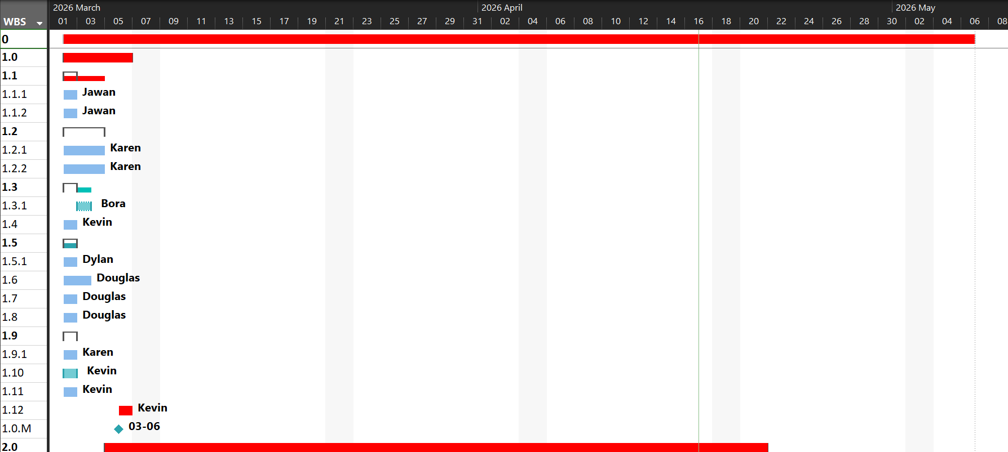
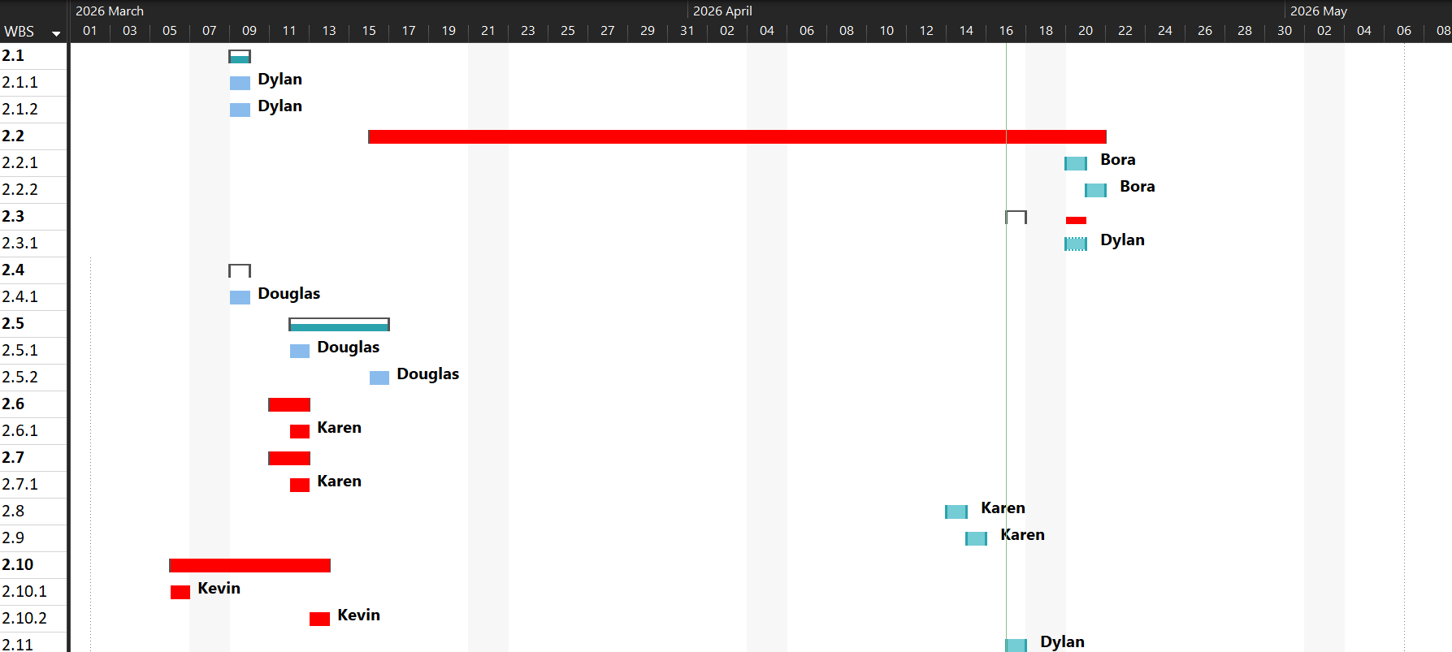
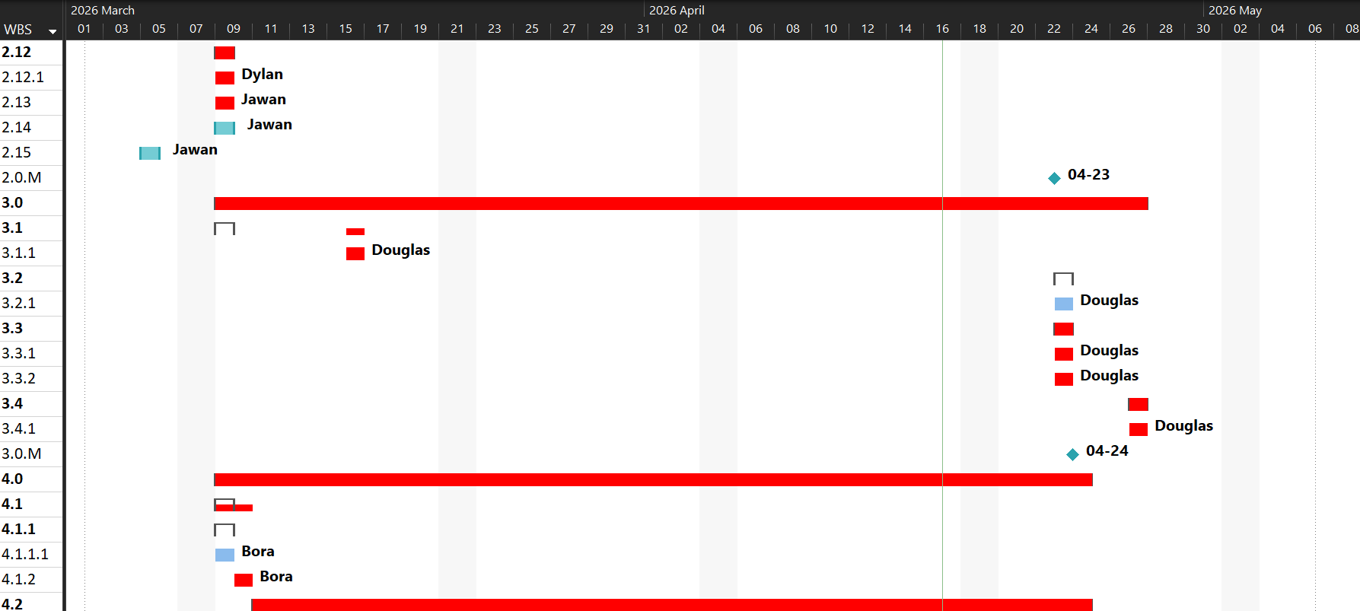
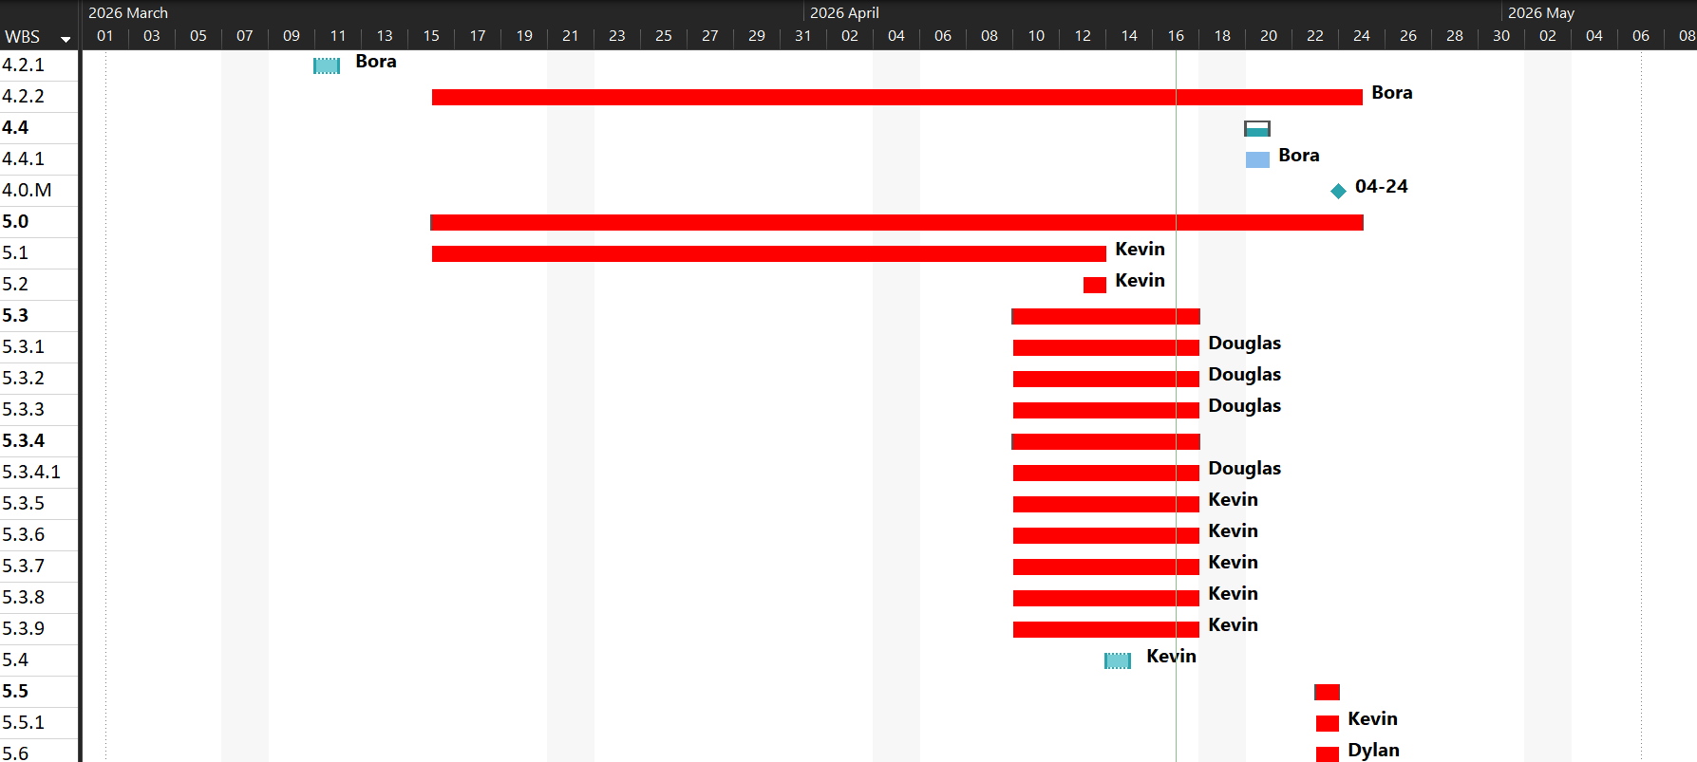
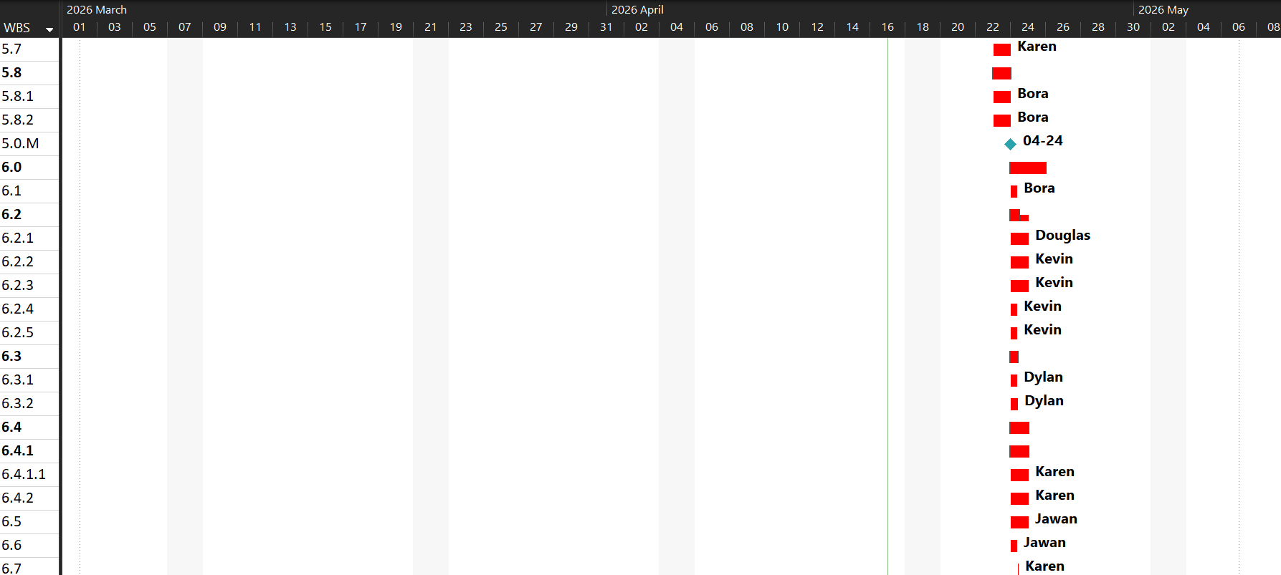
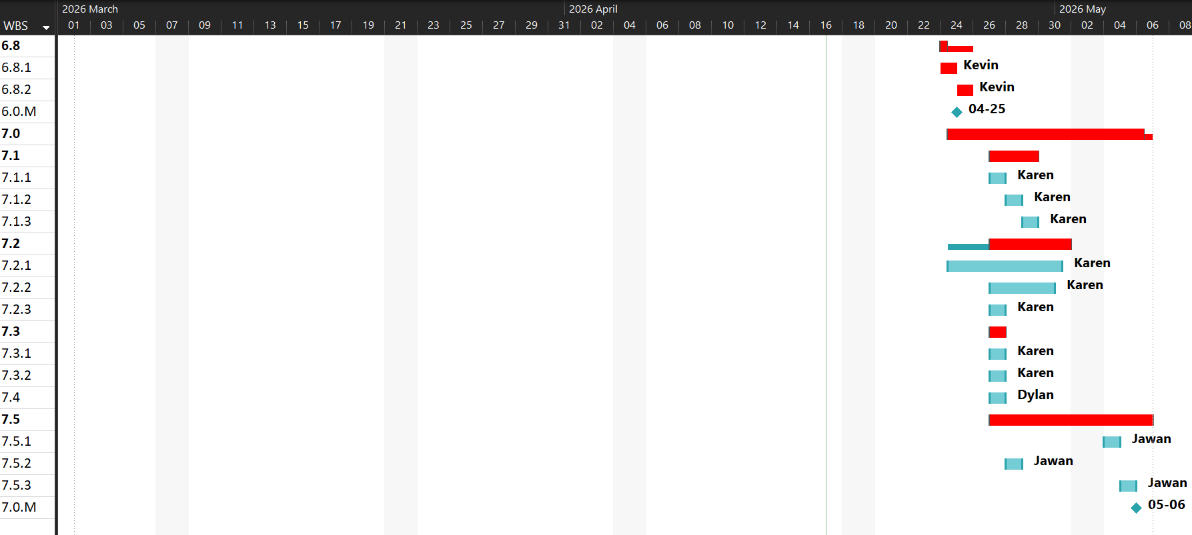

Appendices D – RACI Chart
Task Name | Bora | Douglas | Dylan | Jawan | Karen | Kevin | Attendees | Volunteers | Sponsors
NAIT End of Term LAN Party | R | R | A/R | R | R | R
Research LAN Party | R | R | R | A/R | R | R
Research equipment needed |  |  |  | A/R |  | I
Research network and power requirements for equipment |  |  |  | A/R |  | I
Research peripherals required |  |  |  | A/R |  | I
Research how to book room at NAIT |  | C |  |  | A/R
Inquire about capacity limits |  |  |  |  | A/R
Inquire about equipment that can be provided by NAIT |  |  |  |  | A/R
Research Possible Sponsors | A/R |  |  |  |  | I
Create a sponsor pitch deck | A/R |  |  |  |  | I
Research possible vendors |  |  |  |  |  | A/R
Research games that will be played |  |  | A/R |  |  | I
Research any DLC that would be required |  |  | A/R |  |  | I
Research ways to distribute survey |  | A/R |  |  |  | I
Research NAIT IT policies |  | A/R |  |  |  | I
Research NAIT food policies |  | A/R |  |  |  | I
Research volunteer recruitment channels |  |  | C |  | A/R | I
Research volunteer roles required |  |  | C |  | A/R | I
Research NAIT security policies |  |  |  |  |  | A/R
Research prizes |  |  |  |  |  | A/R
Compile costs |  |  |  |  |  | A/R
Research LAN Party complete
Plan LAN Party | R | R | A/R | R | R | R
Create volunteer roles |  |  | A/R
Create volunteer training manual |  |  | A/R
Create a discord for volunteer communication |  |  | A/R |  |  |  |  | I
Volunteer recruitment | A/R |  | C
Confirm volunteers and availability | A/R |  | C
Create volunteer schedule | A/R |  | C
Create a run of show schedule | C | C | A/R | I | I | C |  | I
Print run of show schedule for event and post on discord and social media |  |  | A/R
Create a safety plan | C | A/R | C | C |  | C |  | I
Print safety plan |  | A/R
Create a code of conduct | C | A/R | C | C
Print code of conduct for event |  | A/R
Post code of conduct on event page |  | A/R |  |  |  |  | I | I
Create registration form | I |  |  |  | A/R
Create QR code for registration form for marketing material | I |  |  |  | A/R
Create food and beverage survey | I |  |  |  | A/R
Create QR code for beverage survey for marketing material | I |  |  |  | A/R
Create pre and post event stress survey |  |  | C |  | A/R
Create quest cards |  |  | C |  | A/R
Contact potential sponsors | C |  |  |  |  | A/R |  |  | I
Create sponsor tracking log |  |  |  |  |  | A/R
Get sponsor logos for marketing materials | I |  |  |  |  | A/R |  |  | I
Create an incident report form | I | I | A/R | I | I | I
Create a budget | C/I | C/I | A/R | C/I | C/I | C/I |  |  | I
Determine amount for contingency fund |  |  | A/R
Create social media account |  |  |  | A/R
Create a risk mitigation plan |  |  |  | A/R
Create a walkthrough checklist |  |  |  | A/R
Plan LAN Party Complete
Venue |  | A/R
Book Venue with NAIT |  | A/R
Finalize venue booking |  | A/R
Create layout plan for the event |  | A/R |  |  | C
Verify power outlet locations |  | A/R |  |  | C
Conduct pre-event walkthrough | I | A/R | I | I | I | I
Go through walkthrough checklist |  | A/R
Document any preexisting damage |  | A/R
Conduct post event walkthrough | I | A/R | I | I | I | I
Go through walkthrough checklist |  | A/R
Venue Complete
Marketing | A/R |  | C |  | C | C | I |  | I
Create marketing assets | A/R |  | C |  | C |  |  |  | I
Create Posters | A/R |  | C |  | C |  |  |  | I
Print posters | A/R
Create graphics for social media and discord posts | A/R |  | C |  | C |  |  |  | I
Post marketing assets around NAIT, discord, and social media | A/R |  |  |  |  |  | I |  | I
Launch registration form | A/R |  |  |  | C |  | I
Weekly event reminders on discord and social media | A/R |  |  |  |  |  | I |  | I
Create event signage | A/R |  | C |  |  | C |  |  | I
Create station signage | A/R |  | C |  |  | C |  |  | I
Marketing Complete
Equipment | R | R | R |  | R | A/R
Send out request for borrowing equipment on discord and social media | C |  |  |  |  | A/R
Secure rentals for any missing consoles, peripherals, or tv's | C |  | C |  |  | A/R
Procure Equipment |  |  | R |  |  | A/R
Procure switches |  | A/R
Procure HDMI and Ethernet cables |  | A/R
Procure gaffers tape |  | A/R
Procure games |  | A/R | C
Procure any DLC that is required |  | A/R | C
Procure cable mats |  |  |  |  |  | A/R
Procure extension cables |  |  |  |  |  | A/R
Procure power bars |  |  |  |  |  | A/R
Procure volunteer lanyards |  |  |  |  |  | A/R |  | I
Procure hand sanitizer and disinfectant wipes |  |  |  |  |  | A/R
Create equipment inventory sheet |  |  |  |  |  | A/R
Label all equipment and cables |  |  |  |  |  | A/R
Ensure all borrowed equipment has contact information |  |  |  |  |  | A/R
Procure Prizes | C |  | A/R
Procure food and beverage |  |  |  |  | A/R
Pre event tech test | R |  |  | A/R |  | C
Power load test | A/R |  |  |  |  | C
Network connectivity test | A/R |  |  |  |  | C
Equipment Complete
Hosting LAN Party | R | R | A/R | R | R | R | I | R | I
Load in equipment | A/R | I | I
Physical setup |  | A/R
Setup furniture |  | A/R |  |  |  | I
Setup gaming stations |  |  |  |  |  | A/R
Cable management |  |  |  |  |  | A/R
Setup food and beverage table |  |  |  |  |  | A/R
Final equipment and network test |  |  |  |  |  | A/R
Assign volunteers their roles |  |  | A/R |  |  |  |  | I
Have safety meeting with volunteers |  |  | A/R |  |  |  |  | I
Train volunteers |  |  | A/R |  |  |  |  | I
Manage check in |  |  | C |  | A/R |  |  | R
Hand out quest cards |  |  | C |  | A/R |  | I | R
Take completed quest cards |  |  | C |  | A/R |  |  | R
Remind guests about pre-event survey |  |  | C |  | A/R |  | I | R
Create event incident reports as needed |  |  |  | A/R
Prize draw |  |  |  | A/R |  |  | I |  | I
Post event survey |  |  | C |  | A/R |  | I | R
Event teardown |  |  | C |  |  | A/R |  | R
Return borrowed equipment |  |  |  |  |  | A/R
Return rented equipment |  |  |  |  |  | A/R
Hosting LAN Party Complete
Post Event | I | I | R | R | A/R | I | I | I | I
Budget reconciliation | C |  | C |  | A/R | C
Collect all receipts | C |  | C |  | A/R | C
Update budget spreadsheet |  |  |  |  | A/R
Calculate final total + Remaining funds |  |  |  |  | A/R
Survey & Feedback analysis |  |  |  |  | A/R
Monitor Survey Responses |  |  |  |  | A/R
Send email reminder for survey |  |  |  |  | A/R |  | I
Summarize key metrics |  |  |  |  | A/R
Final Closeout |  |  |  |  | A/R
Publish/ Share event highlights (photos, recap) |  |  |  |  | A/R |  | I | I
Send thank you notes to stakeholders | C | C | C | C | A/R | C | I | I | I
Analyze event incident reports |  |  |  | A/R | C
Create event report | C | C | C | A/R | C | C
Compile Event statistics |  |  |  | A/R
Add photos and media highlights |  |  |  | A/R
Finalize PDF event report | I | I | I | A/R | I | I
Post Event Complete

Appendices E – Change Request Form
NAIT LAN Party Change Request Form
Change Request ID: Internal Use Only
Date Submitted: Click or tap to enter a date.
Requester Name: Click or tap here to enter text.
Priority Level:
☐ Low (Minor tweak, no impact on event date)
☐ Medium (Adjusts logistics or internal team workflow)
☐ High (Critical, affects budget, venue, or attendee experience)
Description of Proposed Change:
Click or tap here to enter text.
Reason for Change:
Click or tap here to enter text.
Impact
Area of Impact | Description of Effect
☐ Event Schedule | Click or tap here to enter text.
☐ Budget | Click or tap here to enter text.
☐ Resources | Click or tap here to enter text.
☐ Scope | Click or tap here to enter text.

Risk Assessment
What happens if we do (or don’t) do this?
Click or tap here to enter text.
Decision and implementation
To be completed by the Project Lead
Final Decision:
☐ Approve (Proceed to implementation)
☐ Reject (Archive in change log)
☐ Defer (Review again on date: )
Decision Rationale:
Click or tap here to enter text.
Change Owner (If approved)
Team Member
Sign Off:
Project Lead Signature: Click or tap here to enter text.
Date: Click or tap to enter a date.

Appendices F – Risk Matrix
